**Assignment 3**

**1.count the number of directory and files in specific folder.**

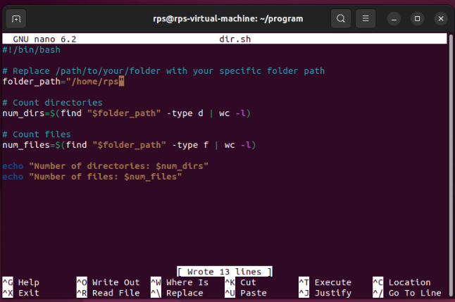

Replace "/path/to/your/folder" with the actual path to the folder you want to count. This script uses the **find** command to search for directories and files recursively starting from the specified folder. The **-mindepth 1** option ensures that the search doesn't include the folder itself in the count. Finally, **wc -l** is used to count the number of lines outputted by the **find** command, which corresponds to the number of directories or files found.

